**LAB # 04**

**ARRAYS IN JAVA**

**OBJECTIVE:** To implement ArrayList and Vector.

# **Lab Tasks**

1. Write a program that takes two arrays of size 4 and swap the elements of those arrays

CODE:

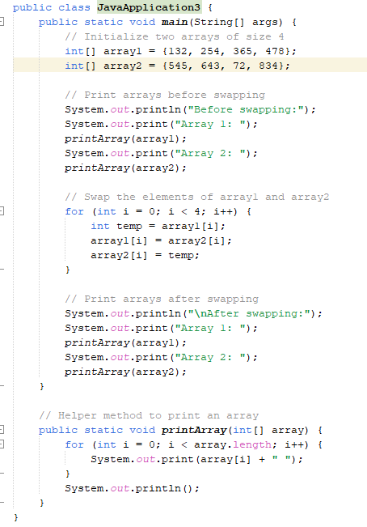

**OUTPUT:**

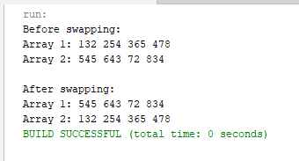

**2: Add a method in the class that takes array and merge it with the existing one.**

**CODE:**

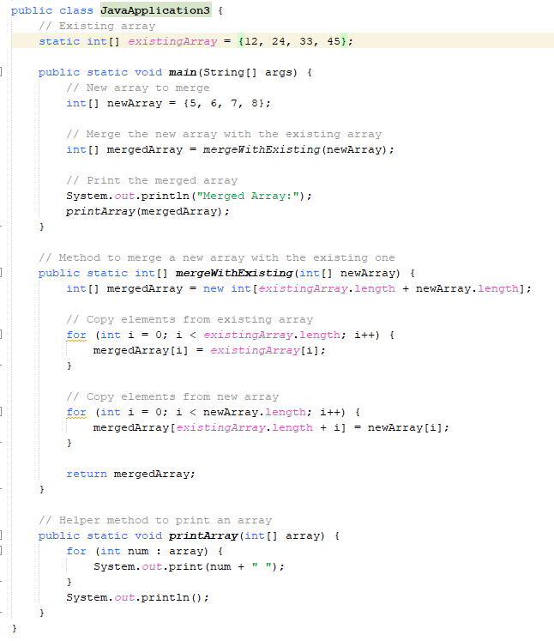

OUTPUT:

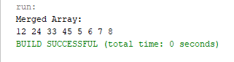

**3. In a JAVA program, take an array of type string and then check whether the strings are palindrome or not.**

**CODE:**

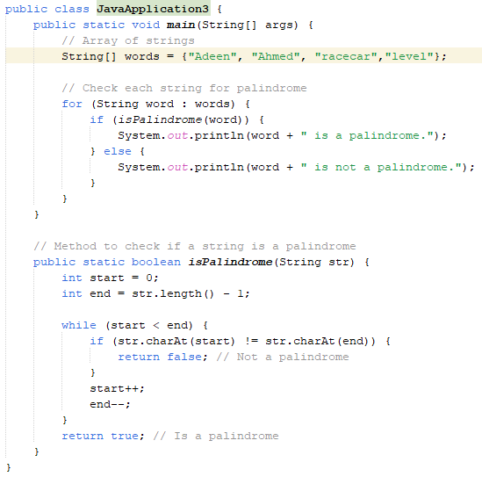

**OUTPUT:**

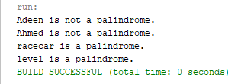

**4. Given an array of integers, count how many numbers are even and how many are odd.**

**CODE:**

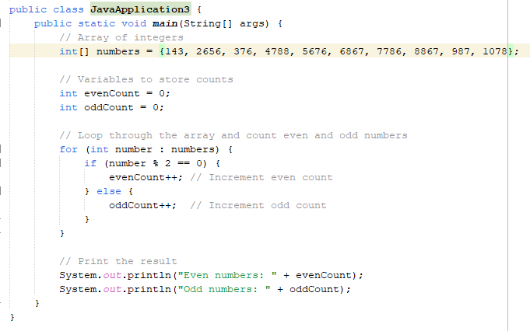

**OUTPUT:**

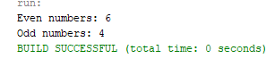

**5. Given two integer arrays, merge them and remove any duplicate values from the resulting array.**

**CODE:**

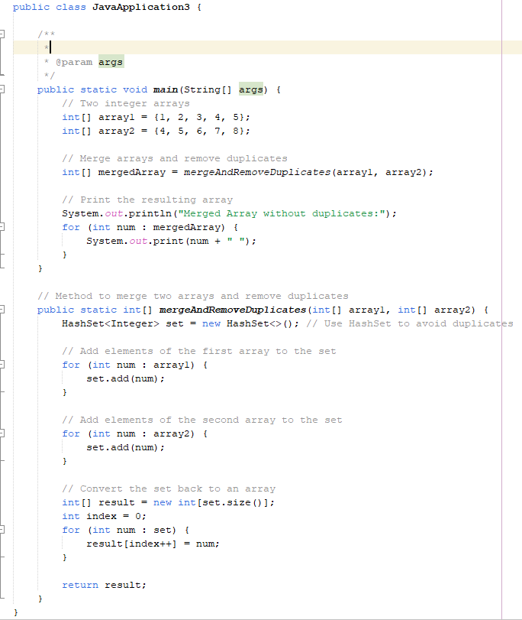

**OUTPUT:**

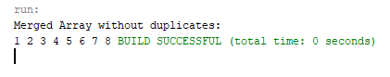

## HOME TASK

**1. Write a program that takes an array of Real numbers having size 7 and calculate the sum and mean of all the elements. Also depict the memory management of this task**

**CODE:**

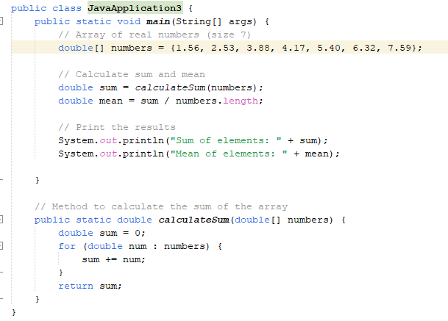

**OUTPUT:**

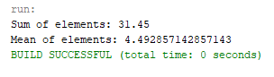

**2. Add a method in the same class that splits the existing array into two. The method should search a key in array and if found splits the array from that index of the key.**

**CODE:**

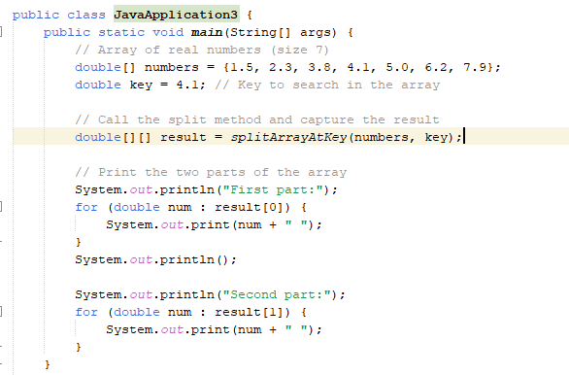

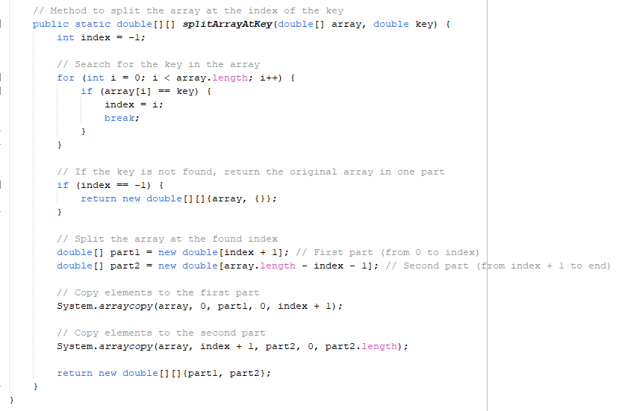

**OUTPUT:**

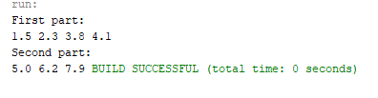

**3. Given an array of distinct integers and a target integer, return all unique combinations of numbers that add up to the target. Each number can be used only once in the combination.**

**CODE:**

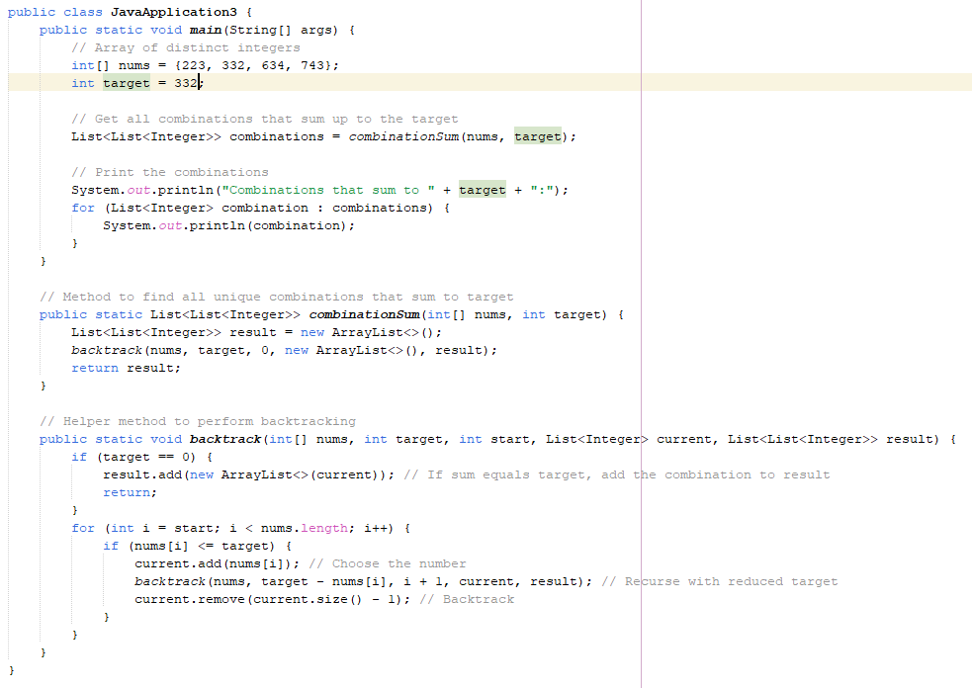 **OUTPUT:**

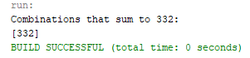

**4. You are given an array containing n distinct numbers taken from 0, 1, 2, ..., n. Write a program to find the one number that is missing from the array.**

**CODE:**

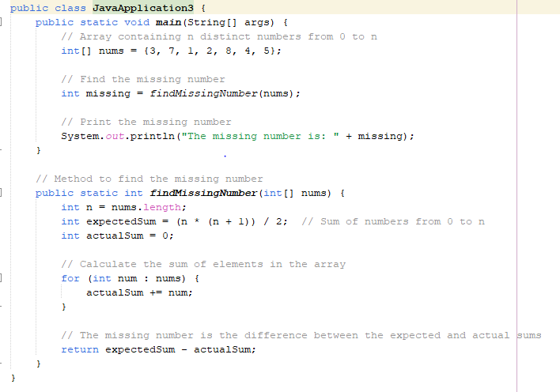

**OUTPUT:**



**5. You are given an array of integers. Write a program to sort the array such that it follows a zigzag pattern: the first element is less than the second, the second is greater than the third, and so on.**

**CODE:**

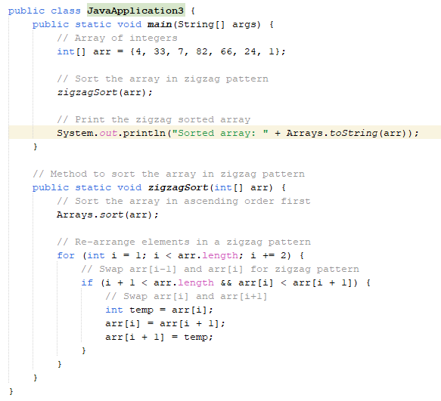

**OUTPUT:**

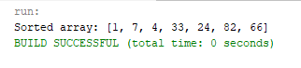

# Home Tasks